Rustitute  
**The plugin that doesn’t say no**



1. Introduction
2. Installation
3. General Information
4. User Commands
5. Owner Commands
6. Arena
7. Achievements
8. To-do List
9. Changelog
10. License

**Introduction**

I played over 500 hours of Rust legacy and loved every second. Rustitute is my attempt to create a plugin which has all of the features from the legacy servers I played on, all of the good ideas for features I’ve seen online and all the features I want myself.

Rustitute is very much a work in progress. I still haven’t implemented some of the basic features some people might like and I have spent far too many hours working on things that nobody else would care about (damn lanterns).

If you have an idea for something or have seen someone else do something you want included in Rustitute, please get in touch!

Some of the features in Rustitute were features thought up by others that I thought were great ideas so I wrote them in. I have rewritten some JS/PY/Lua scripts and I am happy to give credit to anyone who deserves it, just flick me a message. I have rewritten functions from Pluton & Rust as I didn’t like the way they did some things. I liked the way Oxide did some things so some of my code is inspired by them too.

**Installation**

This guide does not cover the installation and setup of Rust or Pluton.

**1) Copy Rustitute files**

* Copy the **Plugins\Rustitute** folder to the **‘Pluton\Plugins’** folder.
* This should include **Rustitute.dll**, **Rustitute.ini**, **RustituteArena.ini** & a folder called **arenas** with a few ini files.
* Copy **LoadOuts\arena.ini** to the **‘Pluton\ LoadOuts’** folder.

**2) Edit Pluton files**

* By default, c# plugins are not enabled.
* Open ‘**RustDedicated_Data/Core.cfg**’ and edit the **[csharp]** section setting **enabled** to true and **checkHash** to false.
* Edit **‘Pluton\Pluton.cfg’** and in the **[Config]** section, set **welcomeMessage** to false. In the **[Commands]** section, set **enabled** to false.

**3) Reload Pluton**

* In the Rust server window (or in Rusty) type **pluton.reload** and you should see a message along the lines of ‘Rustitute plugin was loaded successfully’ as well as at least 1 loadout loaded.

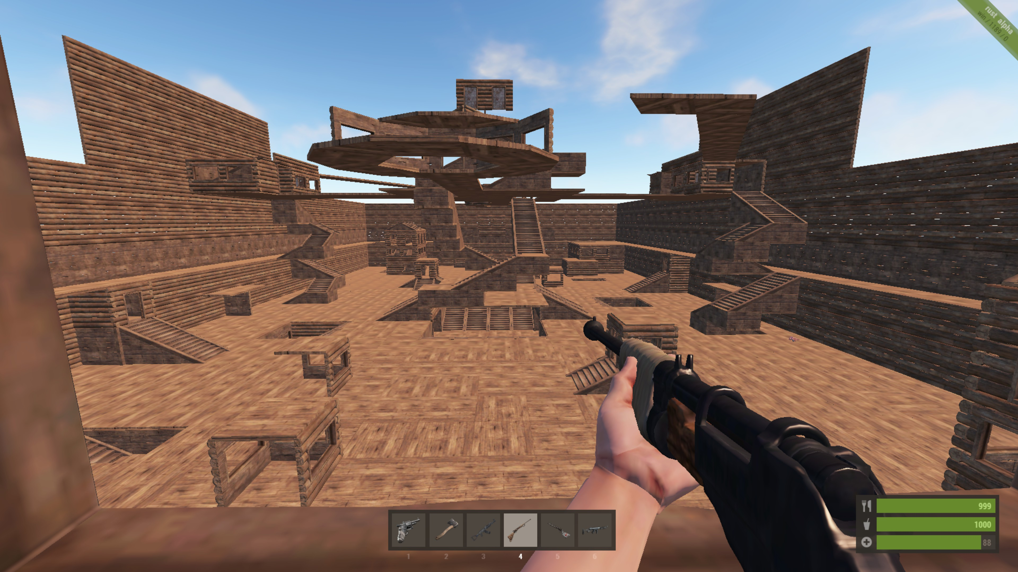

**General Information**

* Any command where you can enter a user’s name will do partial name matching. For example, you can type **/tp jo** to teleport to the user **JohnSmith**.
* The teleport system is disabled for anyone in arena mode.
* Any feature of Rustitute which makes use of collision detection (logging arena, koall mode, destroy mode, etc) **has a limit of 128 colliders**. If you pack too much in a small space it is possible not all of the items will be detected. This is not 128 items, it is 128 colliders and many items have multiple colliders.
* When you reload pluton, the script loses its list of lanterns for the automatic on/off so it will scan the entire arena zone for lanterns which causes the reload to take a few seconds instead of the usual almost instant reloads.
* If you have ‘**server.stability false’** then all building other than in arena build mode will be blocked. This is to help prevent issues with your game saves as unsupported items cause saves to fail.
* A timer runs every 5 minutes which saves all Rustitute settings, player settings and players data to the ini file. This timer also sends reminders to anyone with certain admin abilities turned on.

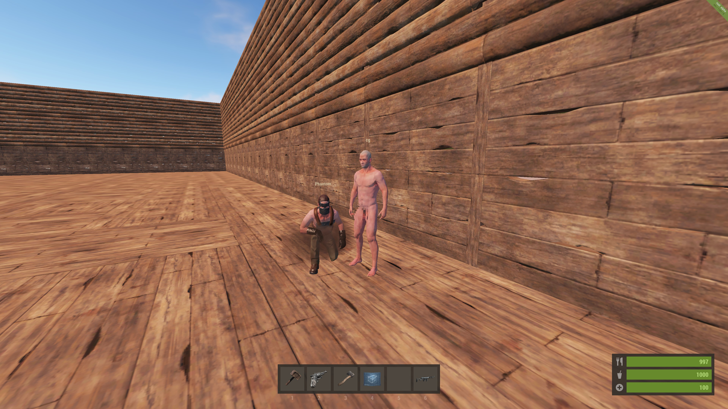

**User Commands**

**/starter**  
Get a basic kit to get you started. Your existing inventory and belt items may interfere with this kit. This currently includes:

* 1x Hammer
* 1x Hatchet
* 1x Building Plan
* 1x Sleeping Bag
* 20x Cooked Wolf Meat
* 1x Pistol
* 25x Pistol ammo

**/tp <user>**  
Teleport to the user. There is currently no request/accept/deny system but that is coming soon.

**/tpsethome**  
Set your home position to the position you are currently at. There are currently no restrictions on where you can set your home position.

**/tphome**Teleport to your home position.

**/players**  
Get a list of all players currently online.

**/arenaplayers**  
Get a list of all players currently in the arena.

**/location**  
Get your current XYZ position and direction.

**/nosleep**  
Toggle whether you are sleeping after spawning.

**/time**  
Get the current time of day.

**/stats <optionalUser>**View your stats or those of another player. Entering no user will show your own stats.

**/achievements <optionalUser>**View your achievements or those of another player. Entering no user will show your own achievements.

**/arena**  
Join or leave the arena. When joining, your inventory will be wiped. I plan to save your inventory but that isn’t high on the todo list atm. When you first join, you will be given a randomly selected outfit that will be your permanent arena outfit. This allows player targeting. When you leave the arena, you will be teleported back to the position you were when you joined the arena. If you leave the server without leaving the arena, your body will be automatically killed.

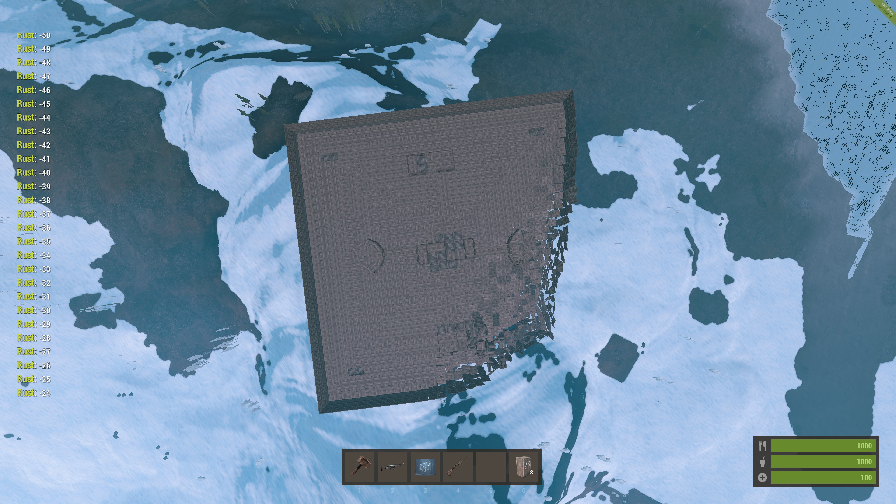

**Owner Commands**

**/aplayers**  
Get a list of all players currently online along with additional information. Currently this shows the players health **H** and the players distance from you **D**.

**/alocation <user>**  
Get the location of that player.

**/tp <user> <toUser>**  
Teleport the first player to the second player.

**/tpto <x> <y> <z>**  
Teleport to the given location.

**/tpto <user> <x> <y> <z>**  
Teleport that player to the given location.

**/tpx**  
Teleport to the position at your crosshair. There is a maximum distance so you may need to do this multiple times to get far across a map.

**/tparena**  
Teleport inside the arena. You will be teleported to the position set by **/arenahere**. This will allow you to get in the arena and build without being in arena mode.

**/time <time>**Set the time of day. This should be a number greater than 0 and less than 24. Set to 17 for 5pm, 13.5 for 1:30pm, etc.

**/heal**  
Completely heal yourself.

**/jump <distance>**  
Teleport by the given distance. Give a position number to jump or a negative number to teleport down. Using god mode and /jump 1500 will give you a nice view of the map.

**/adminkit**  
Kit yourself out with all the stuff you might need. Your existing inventory and belt items may interfere with this kit. This kit currently contains:

* + 1x Assault Rifle
  + 1x Bolt Action Rifle
  + 1x Waterpipe Shotgun
  + 1x Thompson
  + 1x Hunting Bow
  + 1x Hatchet
  + 1x Hammer
  + 1x Building Plan
  + 1x Metal Facemask
  + 1x Metal Chest Plate
  + 1x Urban Pants
  + 1x Urban Boots
  + 1x Leather Gloves
  + 10x Tool Cupboard
  + 10x Code Lock
  + 10x Furnace
  + 10x Large Wood Box
  + 1,000,000x Metal Fragments
  + 1,000,000x Stones
  + 1,000,000x Wood
  + 1,000,000x Cloth
  + 500x Bandages
  + 500x Large Medkit
  + 1,000x Cooked Wolf Meat
  + 10,000x Pistol Bullet
  + 10,000x 5.56 Rifle Cartridge
  + 10,000x Shotgun Cartridge
  + 10,000x Wooden Arrow

**/adminmsg <message>**  
Send message to all logged in admins.

**/botname <name>**  
Change the bot's name.

**/ko**  
Toggle KO mode. KO mode allows you to shoot an object and have it instantly destroyed. Note some objects are not compatible with this mode.

**/koall**  
Toggle KO All mode. Make sure no other building part is within 10m of what you are destroying or it may get included in the chain reaction of destruction. KO All mode is capable of destroying mode objects than KO mode as it detects nearby colliders instead of relying on Pluton hooks.

**/god <optionalUser>**  
Toggle god mode. If you enter a user he/she will have god mode toggled for them even if they are not an Owner. The user will get a message letting them know if you do this. God mode is disabled when you reconnect. When someone attacks you, they will be notified that you have God mode and you will be notified the user attempted to hurt you.

**/motd <optionalMotd>**  
Set or remove the motd. This will be displayed to users when they connect.

**/instabuild**  
Toggle instant building. From the sounds of the devblog, this won’t be required shortly.

**/instamax**  
Toggle building parts being placed at maximum grade (stone, metal, etc). This is not completely stable.

**/copy <distance>**  
Enable copy mode. Enter no distance to disable. Shoot a BuildingBlock to copy it by this distance. For example, **/copy 10** then shooting a foundation will make a copy of the foundation placed exactly 10m above it. Combined with **/ko** mode, this effectively becomes a move rather than copy.

**/arenabuild**  
Allow yourself to build at the arena. Without this enabled, any attempt to build within the arena building zone will result in the immediate destruction of the item without resource refund.

**/destroy <distance>**  
Destroy all objects within a given radius of you. Be very careful not to set this high as if it hits too many colliders things could get slow.

**/destroylantern <distance>**  
Destroy all lanterns within a given radius of you.

**/save**Save all Rustitute data. Use this to save the ini files if you are planning on editing them or if you think you are about to crash the server.

**/load**  
Load all Rustitute data. Use this if you have manually edited the ini files and want to load in the changes. Any changed data since the last save (every 5 minutes) will be lost!

**/kick <user>**Kick this user off the server.

**/ban <user>**  
Ban the user from the server.

**/kill <user>**Kill this user.

**/mute <user>**Toggle mute for this user. When muted, the user will receive a message telling them they are muted any time they attempt to chat.

**/logarena**  
Save the arena structure to file. This will detect all BuildingBlock’s and Lantern’s around the arena location set by **/arenahere**. I plan on saving other items too like storage boxes, bear traps, etc. This will scan from -100m to +100m on the x, y & z from the arena location. **Warning:** This is a slow command! My arena is ~5,000 items over 100sqm and the server is unresponsive for ~10 seconds while saving it.

**/destroyarena**  
Destroy the arena. If you are making use of ‘**server.stability false**’ and you have unsupported BuildingBlock’s you need to destroy them before restarting the server or else the save will not load. This is a Rust bug unrelated to the arena or Rustitute.

**/spawnarena**  
Spawn the arena from the saved file.

**/respawnarena**  
Destroys then Spawns the arena.

**/addspawn**Adds a possible respawn location for the arena.

**/togglearena**  
Toggle if the arena is enabled. Enable this once your arena is built or you could disable it if you only want the arena on at certain times.

**/fx <optionalUser> <effect>**  
Trigger an effect to happen for the user or if no user is entered, trigger the effect to yourself. This command is not listed in the help section and could cause problems if not used properly. Here are a few examples but you can send any item from the ‘fx/’ prefabs list.

* **/fx door/open_start**Play a door opening sound to the user
* **/fx screen_jump**Bounce the users screen
* **/fx animals/wolf/attack1**Play a wolf attacking sound to the user

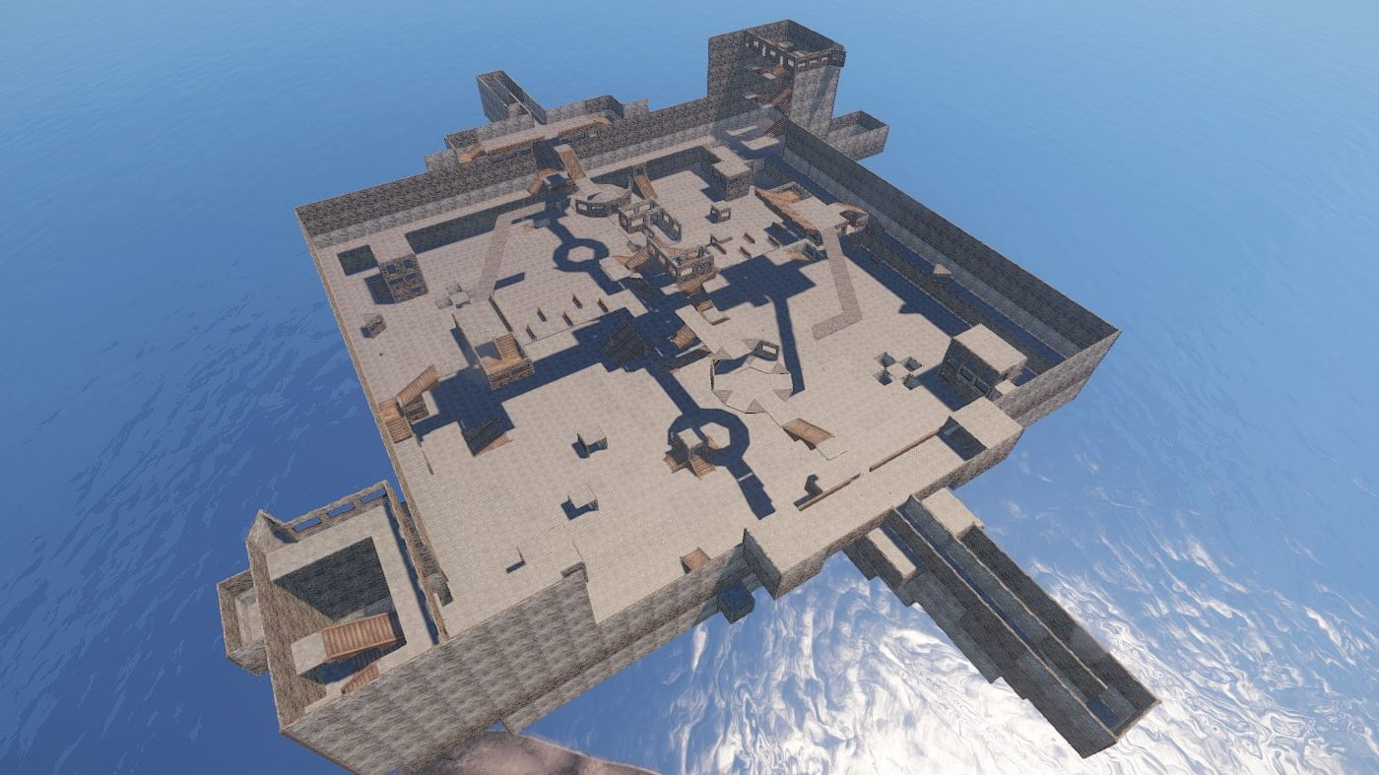

**Arena**

Create an arena and battle it out! The arena has no fall damage and no bleeding. Any doors placed in the arena will be locked to anyone in arena mode and using them will teleport the user to a random arena spawn point.

When you join the arena, you are naked and invulnerable for 10 seconds. This gives you time to select your weapon and find a safe spot. When the 10 seconds are up, you will receive your clothes which lets others know you are ready for action.

All melee weapons have been upgraded to instant kills.

You can alter the arena kit by editing the **arena.ini** LoadOut file.

The Arena cannot be damaged by anyone unless they are in arena building mode and are also not currently in arena mode. This prevents people breaking in/out of the arena.

To begin creating an arena, make sure you empty the **[ArenaSpawn]** section in the **Rustitute.ini** file before starting the server (or edit while live then use **/load**). I will add a command to do this for you at some point during the rework to allow multiple arenas.

With that section empty, you can start the server and go to a location you want your arena and type **/arenahere**. This will prevent other users building within 300m 2D from this point.

You can build your arena like a regular base, you can make it open and use the terrain or you can build it in the sky (using /copy then /jump to get up there to continue building). If you build in the sky or you otherwise end up having the center point of your arena change you should enter **/arenahere** again.

I recommend you seal off your arena either will walls/floors etc or by having walls a few levels above possible jumping height. This prevents users from running off with the arena kit (all that ammo!) and prevents users from dropping their kit over the edge or through windows.

When your arena is built, type **/logarena** to save it to file. Do this again any time you make a change to it. Your arena will be saved to file and if you accidentally overwrite your arena you can view all your old saved arenas in the **‘arenas’** subfolder of the Rustitute plugin folder.

Your arena will need spawn points. Move around the arena and type **/addspawn** to add a spawn point at your current location. You must have at least 1 and you can add as many as you like.

You can add Lanterns around the map so players can see at night. The lanterns will automatically turn on when it gets dark and turn off when it gets light. The automatic lanterns will only work with lanterns respawned using **/spawnarena**. If a user tries to turn on/off a lantern, it will adjust itself again within seconds.

You can clear your arena by typing **/destroyarena**. This is very fun to watch – Just remember to log the arena before destroying it!

If you have added lanterns and want them to turn on/off automatically, type **/respawnarena** to destroy the arena and spawn it again. Remember you can **/tparena** to quickly get back up to the arena after you spawn it.

Once your arena is built and ready for players, type **/togglearena** to enabled the arena.

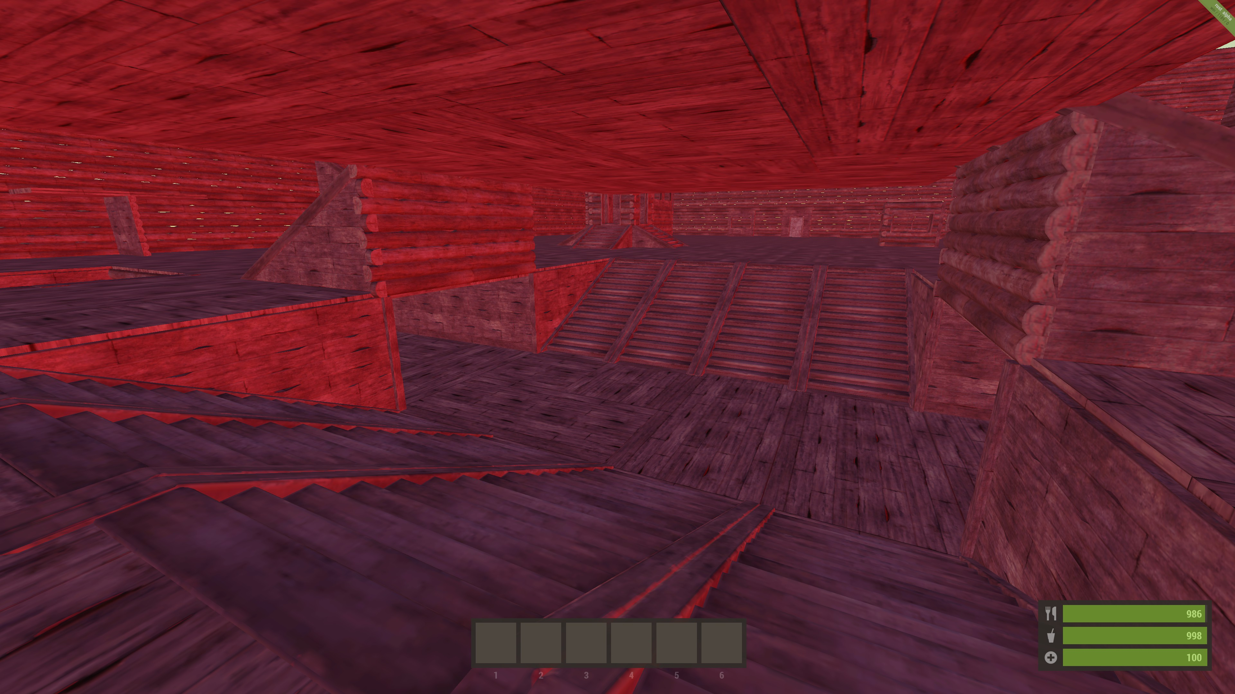

**Achievements**

Rustitute features an Achievement system! Completing certain things will result in achievements. When you get an achievement, the server will broadcast a congratulation message along with the achievement you got to everybody online. You can view your achievements or other players achievements with the **/achievements** command.

The current achievements are:

* Joined the Arena
* Get a kill while you have 5 or less health
* Get 10 Kills
* Get 100 Kills
* Get 1,000 Kills
* Get 10,000 Kills
* Get 10 Headshots
* Get 100 Headshots
* Get 1,000 Headshots
* Get 10,000 Headshots
* Died 10 Times
* Died 100 Times
* Died 1,000 Times
* Died 10,000 Times
* Killed 10 sleepers
* Killed 100 sleepers
* Killed 1,000 sleepers
* Killed 10,000 sleepers
* Hit someone over 50m away while they are running
* Hit someone over 100m away while they are running
* Hit someone over 200m away while they are running
* Hit someone over 50m away while they are in the air
* Hit someone over 100m away while they are in the air
* Hit someone over 200m away while they are in the air
* Hit someone over 100m away
* Hit someone over 200m away
* Hit someone over 300m away
* Hit someone over 500m away
* Killed someone over 50m away
* Killed someone over 100m away
* Killed someone over 200m away
* Killed someone over 300m away
* Killed someone over 400m away
* Killed someone over 500m away

I’m pretty sure the ‘hit someone while they are running’ one is currently impossible as the IsRunning() bool seems to be set to always false.

I am going to add more difficult achievements like distance shooting with arrows, etc. If you have any ideas for some fun or difficult achievements, get in touch!

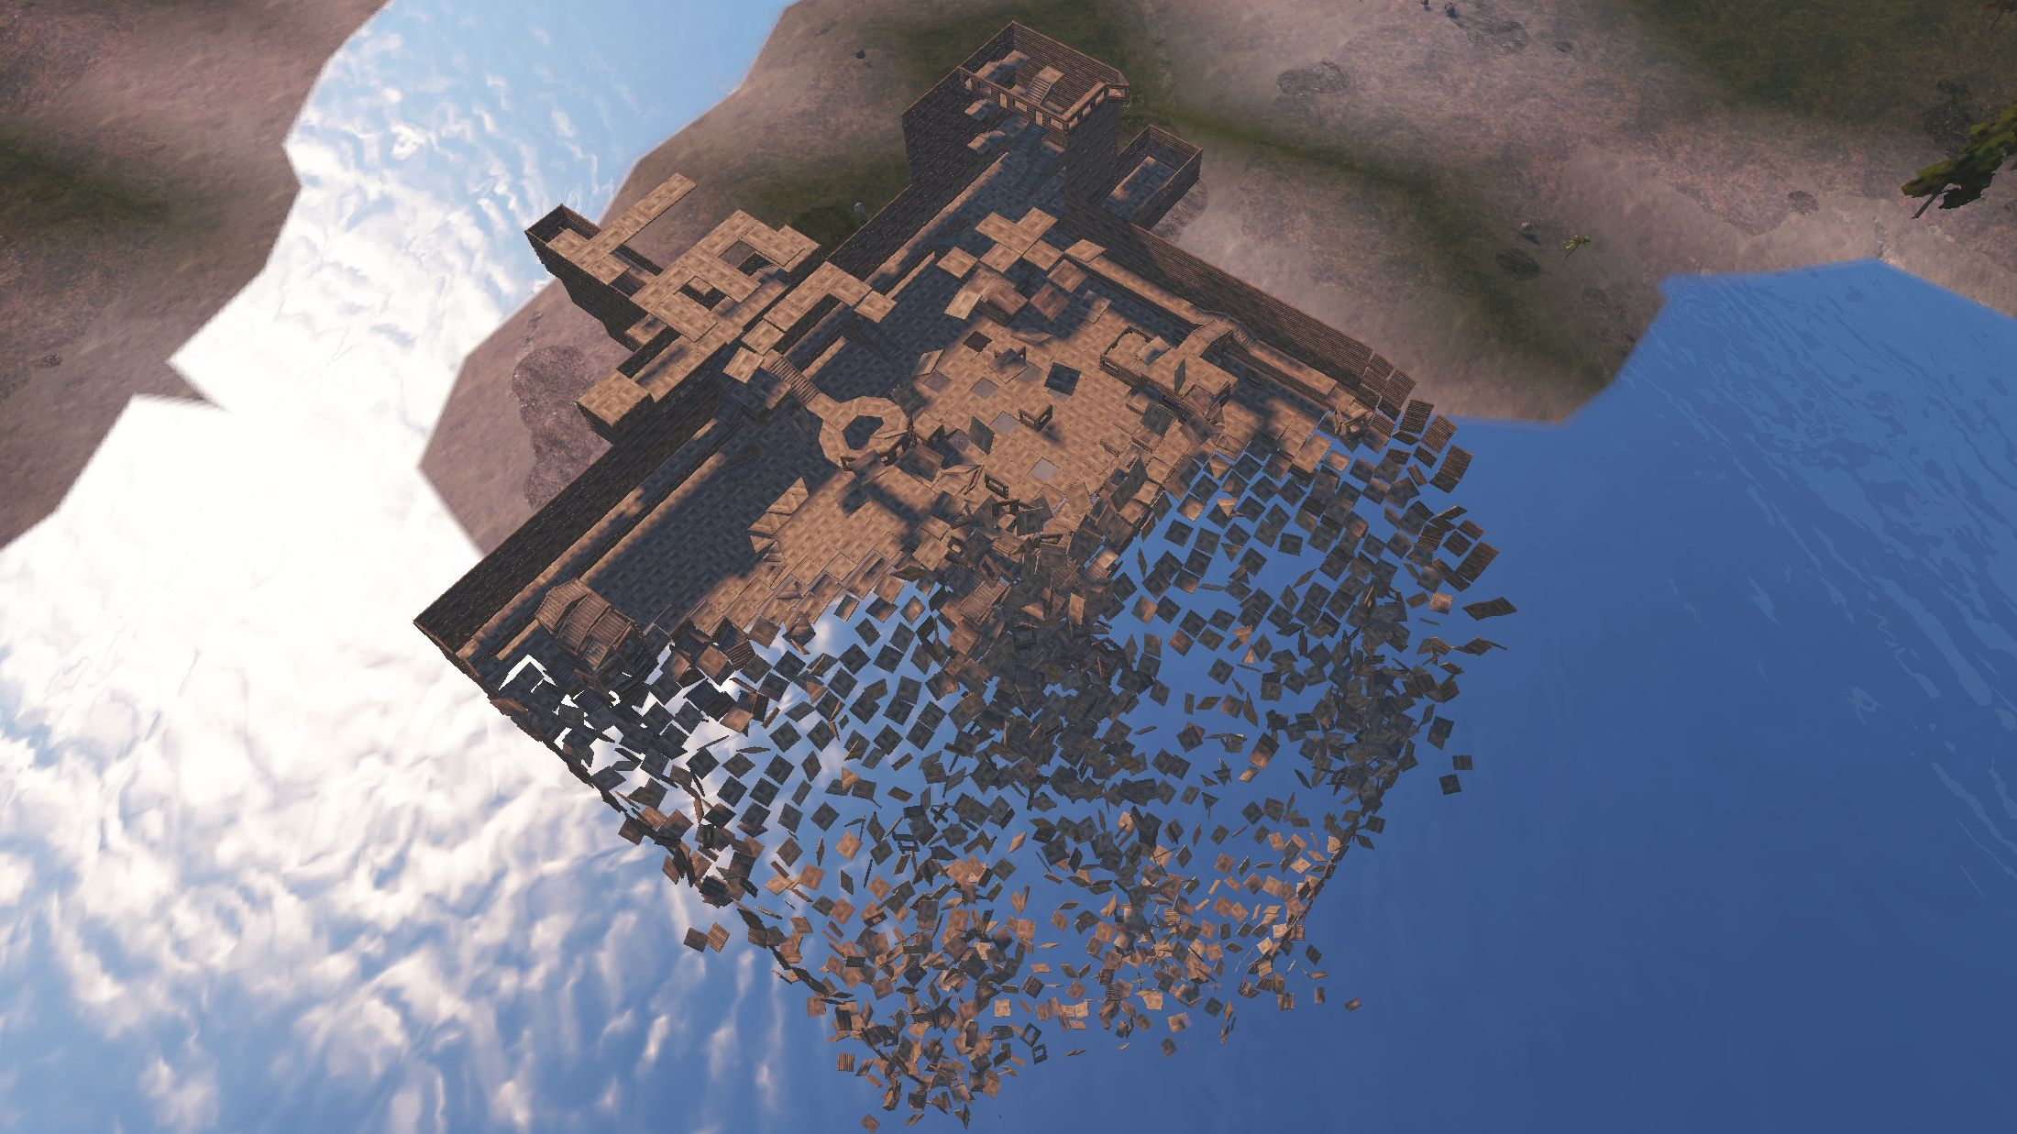

**To-do List**

* Top 10 List (Kills, Deaths, Ratio, etc)
* Top 10 List for Arena
* /starter and /adminkit should use LoadOuts so they can be easily altered
* Add ability to have multiple arenas
* Add ability to clear out all arena spawns so you can start over without editing the ini file.
* More achievements – Distance shooting with arrows, etc.
* Improve teleport system: Add request/allow/deny/whitelist etc.
* Restrict usage of /tpsethome. Ideally prevent setting home position when in a building blocked zone, etc.
* Save inventory items for players when they join the arena.
* Improve arena logger to save other items like storage boxes, etc.
* See if there is a way around the ‘server.stability false’ issues.
* Private messaging.
* Moving text from the plugin to ini files so people can alter it.
* Some secret fancy awesome things from our old legacy arena :D

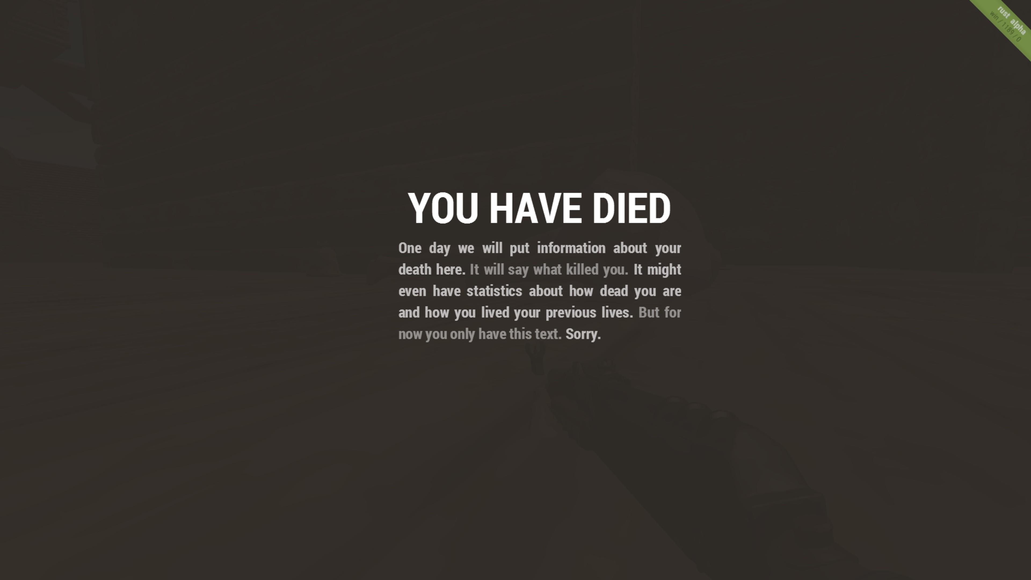

**Changelog**

**1.0.5519.20973** – 10 Feb 2015

* Fixed /ko mode for new Pluton update

**1.0.5517.40615** – 8 Feb 2015

* Added custom SendMessage function as Pluton seems to currently have a few issues with Player.MessageFrom(), Player.Message(), Server.Broadcast() and Server.BroadcastFrom().
* Added new commands: /kick, /ban, /kill, /mute, /silence, /togglearena, /save & /load.
* Removed levenshtein partial names matching system. Worked great for typo’s but terrible for short names.

**1.0.5517.18270** – 8 Feb 2015

* Initial public release

**License**

Copyright © 2015, Geoff Woollams  
All rights reserved

Redistribution and use in binary form, without modification, is permitted provided that the following conditions are met:

1. Redistributions in binary form must reproduce the above copyright notice, this list of conditions and the following disclaimer in the documentation and/or other materials provided with the distribution.
2. This software will not be used for commercial purposes.

THIS SOFTWARE IS PROVIDED BY THE COPYRIGHT HOLDERS AND CONTRIBUTORS "AS IS" AND ANY EXPRESS OR IMPLIED WARRANTIES, INCLUDING, BUT NOT LIMITED TO, THE IMPLIED WARRANTIES OF MERCHANTABILITY AND FITNESS FOR A PARTICULAR PURPOSE ARE DISCLAIMED. IN NO EVENT SHALL THE COPYRIGHT OWNER OR CONTRIBUTORS BE LIABLE FOR ANY DIRECT, INDIRECT, INCIDENTAL, SPECIAL, EXEMPLARY, OR CONSEQUENTIAL DAMAGES (INCLUDING, BUT NOT LIMITED TO, PROCUREMENT OF SUBSTITUTE GOODS OR SERVICES; LOSS OF USE, DATA, OR PROFITS; OR BUSINESS INTERRUPTION) HOWEVER CAUSED AND ON ANY THEORY OF LIABILITY, WHETHER IN CONTRACT, STRICT LIABILITY, OR TORT (INCLUDING NEGLIGENCE OR OTHERWISE) ARISING IN ANY WAY OUT OF THE USE OF THIS SOFTWARE, EVEN IF ADVISED OF THE POSSIBILITY OF SUCH DAMAGE.

No other redistribution or use is permitted without express permission by the copyright holder.

